Matlab code - Yinan

close all; clc;

%initial parameters

Nx = 100;

xmin = 0;

xmax = 1;

tmin = 0;

tmax = 100;

period = 0.4;

omega = 2*pi/period;

safety = 0.45; % have this less than 0.5

%conditions

A0 = .5;

beta = 10;

rho = 1;

P0=0;

c = sqrt(beta/(2*rho))*A0^(1/4);

FA = @(A,Q) Q;

FQ = @(A,Q) (beta/(2*rho))*sqrt(A0)*A;

%mesh in time and space

dx = (xmax-xmin)/(Nx+2);

dt = safety*dx/c;

Nt = floor(tmax/dt);

%Riemann invariant

l1 = c;

l2 = -c;

W1 = @(A,Q) ((Q/A0) + (c/A0)*A);

W2 = @(A,Q) ((Q/A0) - (c/A0)*A);

xvec = linspace(xmin,xmax,Nx+2);

tvec = linspace(tmin,Nt*dt,Nt);

Avec = zeros(Nx+2,1);

Qvec = zeros(Nx+2,1);

Avec_old = zeros(Nx+2,1);

Qvec_old = zeros(Nx+2,1);

Avec_poshalf = zeros(Nx+2,1);

Qvec_poshalf = zeros(Nx+2,1);

Avec_neghalf = zeros(Nx+2,1);

Qvec_neghalf = zeros(Nx+2,1);

%initial condition

for x = 1:length(xvec)

Avec(x,1) = A0;

Qvec(x,1) = 0.0;

end

Qmat=zeros(1,length(tvec));

Amat=zeros(1,length(tvec));

Pmat=zeros(1,length(tvec));

%Lax-Wendroff Scheme 2 step

for t = 1:length(tvec)-1

disp(tvec(t))

% compute extrapolated Riemann invariants

xleft = xmin-l2*dt; % computing the tails of the characteristic curves.

xright = xmax-l1*dt;

Aleft = interp1(xvec,Avec(:,1),xleft);

Qleft = interp1(xvec,Qvec(:,1),xleft);

Aright = interp1(xvec,Avec(:,1),xright);

Qright = interp1(xvec,Qvec(:,1),xright);

W2left = W2(Aleft,Qleft);

W1right = W1(Aright,Qright);

% populate boundary conditions

Qvec(1,1) = A0*W2left + Avec(1,1)*c;

Qvec(end,1) = A0*W1right - Avec(end,1)*c;

% store previous timestep

Avec_old = Avec;

Qvec_old = Qvec;

%interior points

for x = 2:length(xvec)-1

Avec_poshalf(x,1) = .5*(Avec_old(x+1,1)+Avec_old(x,1))-(dt/(2*dx))*(FA(Avec_old(x+1,1),Qvec_old(x+1,1))-FA(Avec_old(x,1),Qvec_old(x,1)));

Avec_neghalf(x,1) = .5*(Avec_old(x,1)+Avec_old(x-1,1))-(dt/(2*dx))*(FA(Avec_old(x,1),Qvec_old(x,1))-FA(Avec_old(x-1,1),Qvec_old(x-1,1)));

Qvec_poshalf(x,1) = .5*(Qvec_old(x+1,1)+Qvec_old(x,1))-(dt/(2*dx))*(FQ(Avec_old(x+1,1),Qvec_old(x+1,1))-FQ(Avec_old(x,1),Qvec_old(x,1)));

Qvec_neghalf(x,1) = .5*(Qvec_old(x,1)+Qvec_old(x-1,1))-(dt/(2*dx))*(FQ(Avec_old(x,1),Qvec_old(x,1))-FQ(Avec_old(x-1,1),Qvec_old(x-1,1)));

end

for x = 2:length(xvec)-1

Avec(x,1) = Avec_old(x,1)-(dt/dx)*(FA(Avec_poshalf(x,1),Qvec_poshalf(x,1))-FA(Avec_neghalf(x,1),Qvec_neghalf(x,1)));

Qvec(x,1) = Qvec_old(x,1)-(dt/dx)*(FQ(Avec_poshalf(x,1),Qvec_poshalf(x,1))-FQ(Avec_neghalf(x,1),Qvec_neghalf(x,1)));

end

% set boundary conditions for A

if tvec(t)<period

Avec(1,1) = ((sin(omega*tvec(t+1))/beta-P0/beta) + sqrt(A0))^2;

Avec(end,1) = A0;

else

Avec(1,1)=A0;

Avec(end,1)=A0;

End

%Avec(1,1) = ((sin(omega*tvec(t+1))/beta-P0/beta) + sqrt(A0))^2;

%Avec(end,1) =A0;

%Calculate flow in the future

Qvec(1,1) = A0*W2left + Avec(1,1)*c;

Qvec(end,1) = A0*W1right - Avec(end,1)*c;

figure(1)

subplot(2,1,1), plot(xvec,Qvec(:,1),'linewidth',4);

ylim([-1 3])

title("Flow v. Position");

xlabel("Position");

ylabel("Flow");

subplot(2,1,2), plot(xvec,Avec(:,1),'linewidth',4);

ylim([0 2])

title("Area v. Position");

xlabel("Position");

ylabel("Area of Vessel");

pause(0.001)

Qmat(1,t)=Qvec(floor(Nx/2),1);

Amat(1,t)=Avec(floor(Nx/2),1);

Pmat(1,t)=P0 + beta.*(sqrt(Avec(floor(Nx/2),1)) - sqrt(A0));

end

figure(2)

plot(tvec,Qmat(1,:)); hold on

title("Flow over Time");

xlabel("Time");

ylabel("Flow");

figure(3)

plot(tvec,Amat(1,:)); hold on

title("Area over Time");

xlabel("Time");

ylabel("Area of Vessel");

figure(4)

plot(tvec,Pmat(1,:)); hold on

title("Pressure over Time");

xlabel("Time");

ylabel("Pressure");

Results:

Firgure1

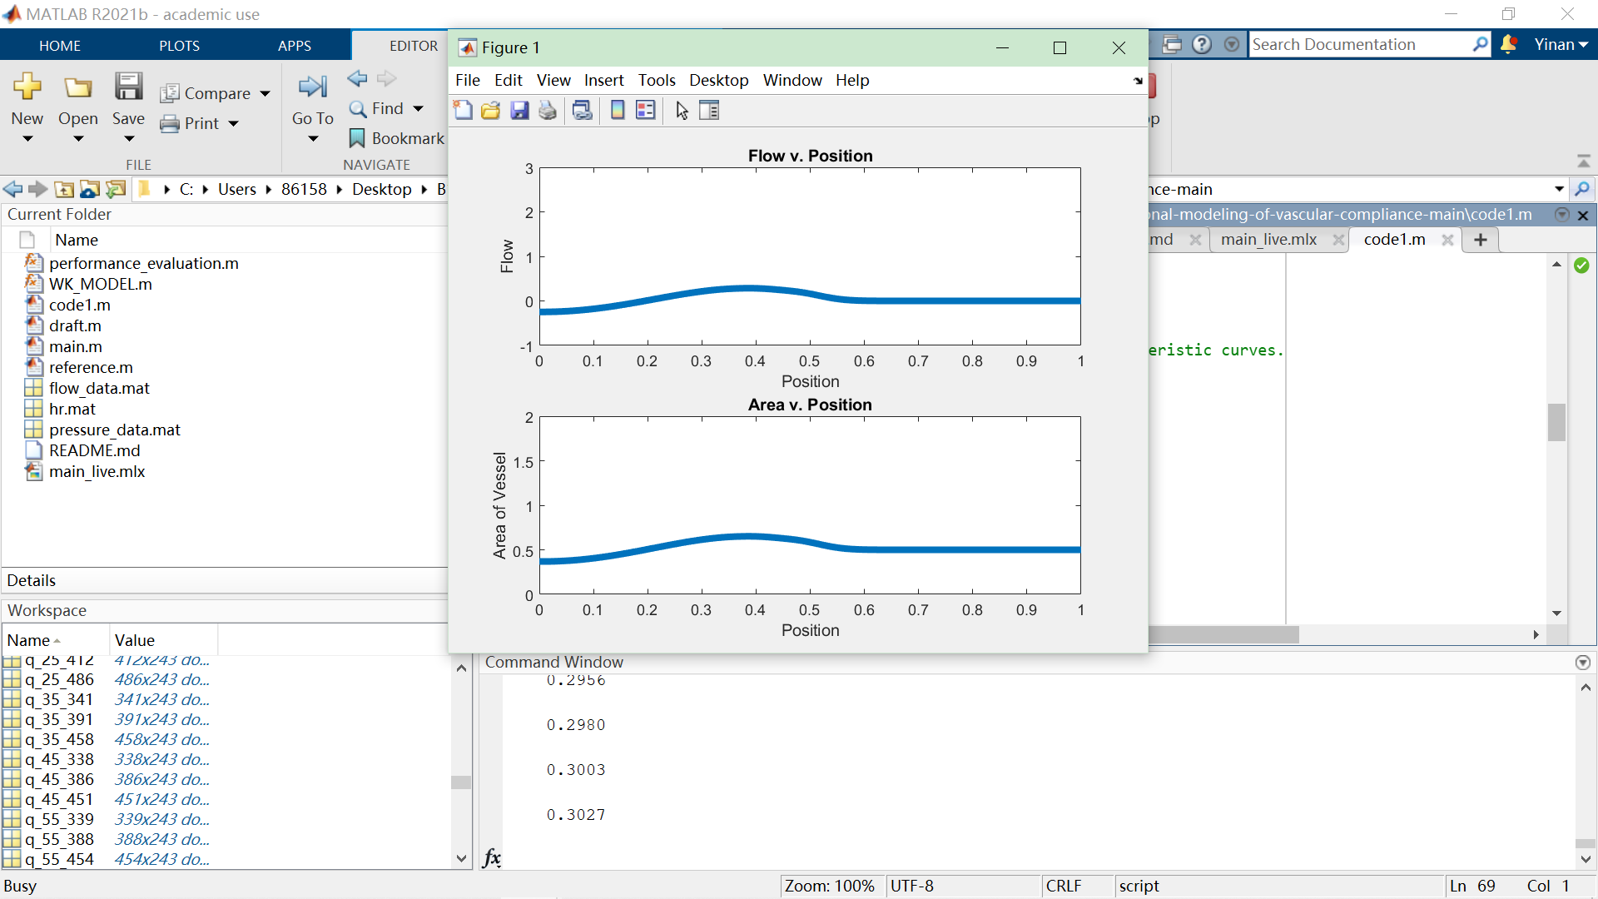

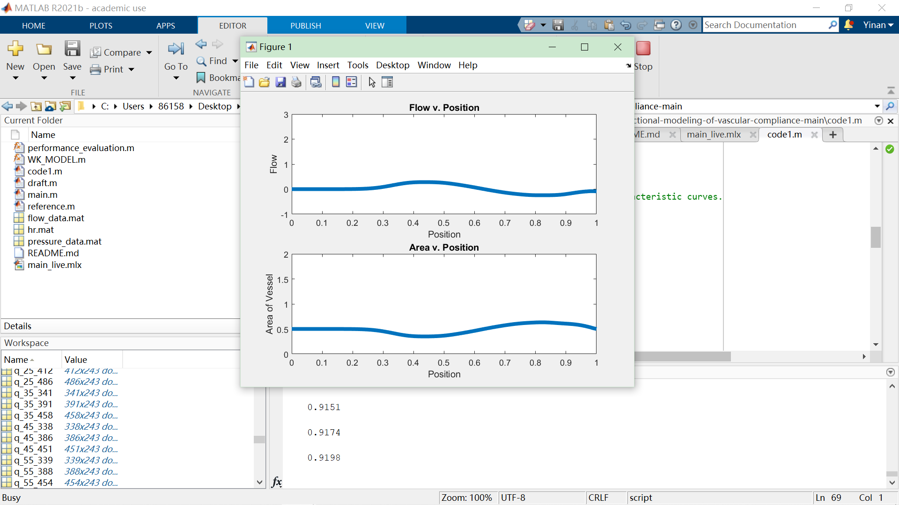

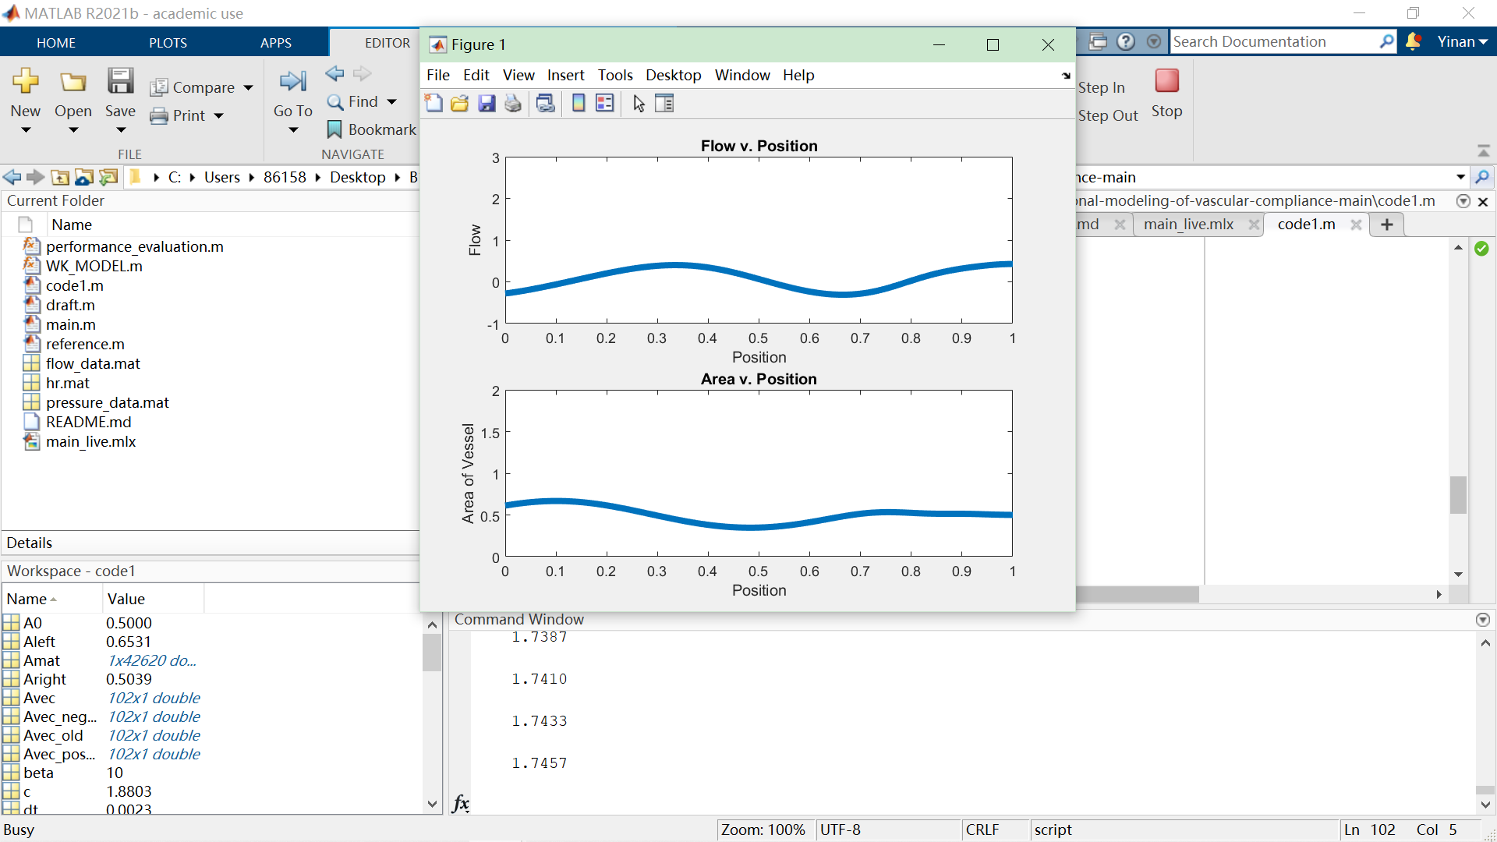

Value changes with time.

But the figure 2,3,4 didn’t show. Something wrong with the code circle, I can’t get the blood pressure over time.